**Lab 07 Submission Template**

**Name:** Carlos Timoteo

**Student Number:** 040905599

You need to submit 6 screen captures. Screen captures must comply with all requirements to get full marks, zero (0) otherwise.

***Lab07P2-DNS* (1 mark)**

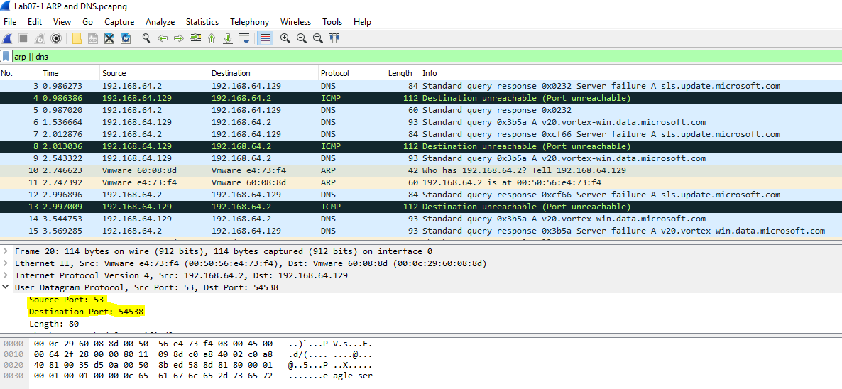

***Lab07P2-TFTP* (1 mark)**

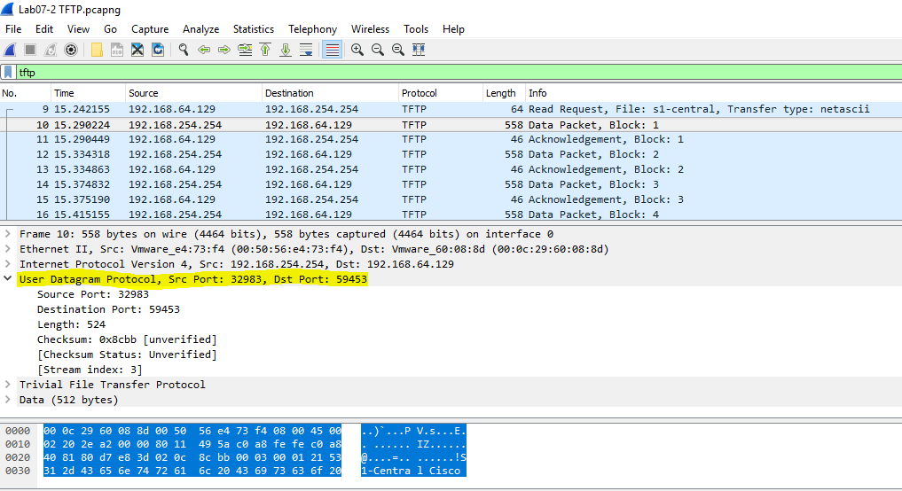

***Lab07P2-HTTP1* (1 mark)**

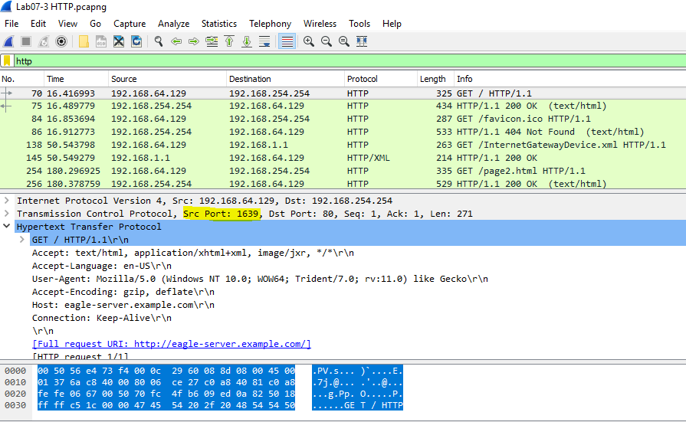

***Lab07P2-HTTP2* (1 mark)**

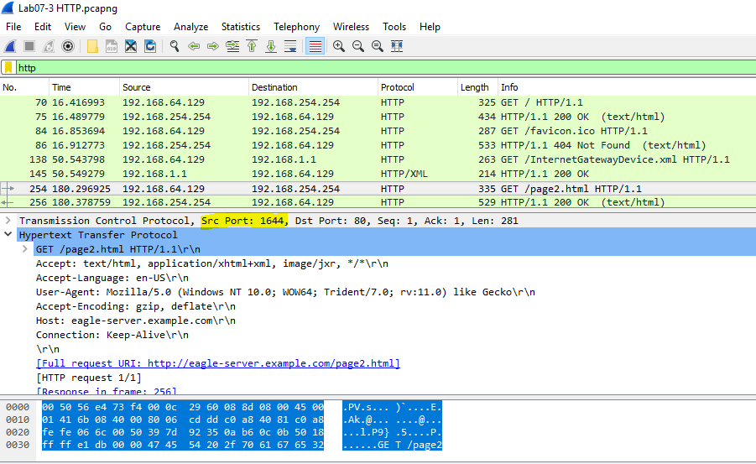

***Lab07P2-DHCP* (1 mark)**

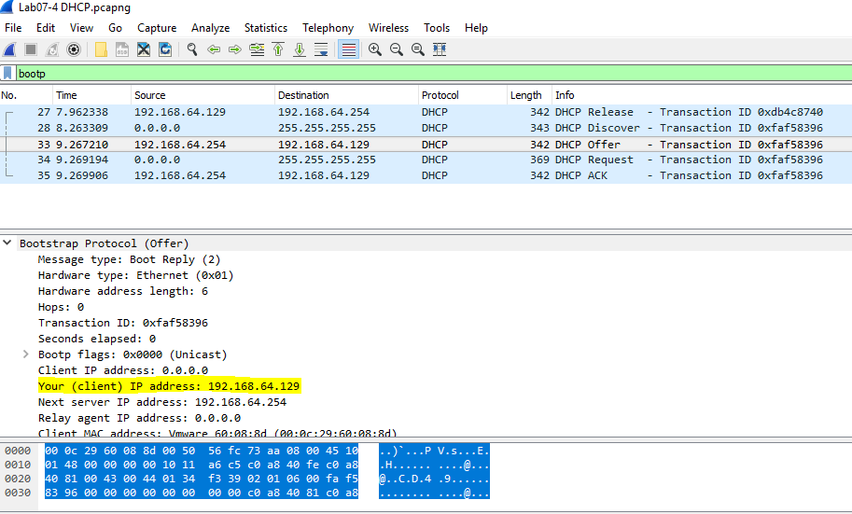

***Lab07P2-FTP* (1 mark)**

